A three-year labour of love for humanity

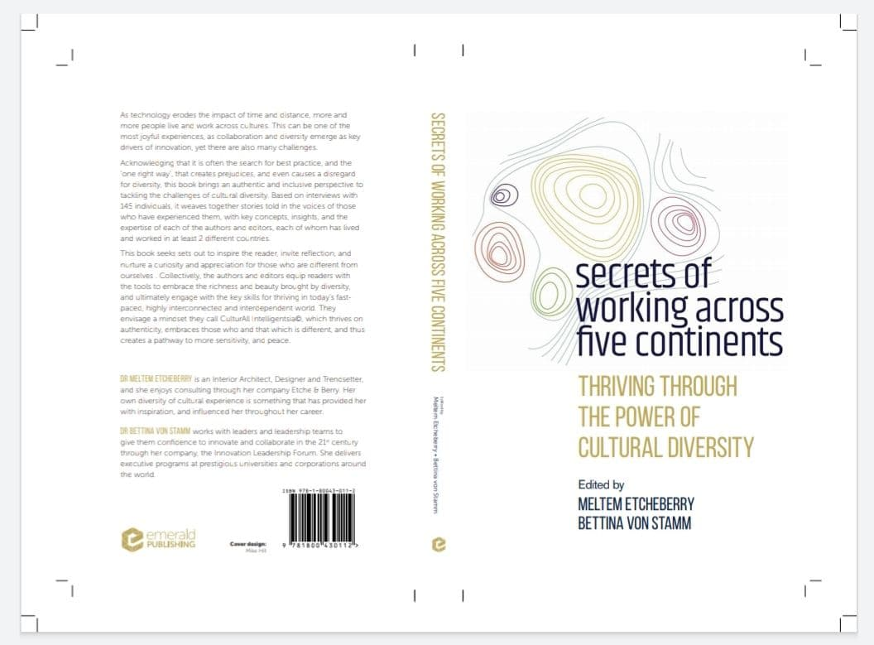

We are delighted to announce the publication of our book :

Secrets of Working Across Five Continents
Thriving through the power of Cultural Diversity

Emerald Publishing - 20/11/2020 London.

This book sets out to inspire the reader, invite reflection, and nurture curiosity and appreciation for those who are different from ourselves.

Respect and love of Cultural Diversity are more and more impactful for sensitivity and peace.

145 contributors from more than 110 countries shared with us their amazing business and life experiences, insights, and stories in terms of Cultural Diversity, captured in 4 main chapters :

- Visionary & Authentic Leadership
- Nurturing People & Culture
- Innovative Design & Creation
- Inspiring Communication & Relationship

Enjoy reading !

Please contact us on our website : www.sowa5c.com
Editors & Lead Authors :

Meltem Etcheberry
Bettina von Stamm

Co-Authors :

Chris Igwe
Hande K. Binns
Triana Navarro de Chollet
Maria Goulina Rabany



You can access our book through the link below :
https://books.emeraldinsight.com/page/detail/Secrets-of-Working-Across-5-ContinentsSecrets-of-Working-Across-Five-Continents/?k=9781800430112

